Download all Assignment Submitted 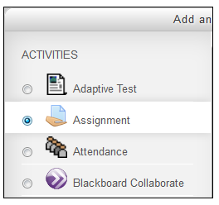
Once students submit their work electronically, instructors may download all the students’ uploaded documents at once in a zipped folder. Doing so saves the instructor time.

Contents
- Steps to Download all files submitted by students

Download all Files Submitted by Students
- Go to the course home page.
- Click on the Assignment activity on the home page.
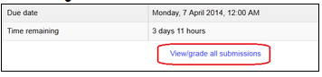
- Click View/grade all submissions.

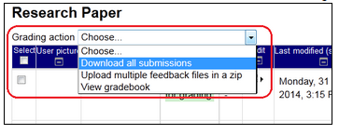
- Choose Download all submissions from Grading action.

- Select the place (a folder or desktop, etc.) where you want to save submissions and click on the OK or Save button.
The files will be saved as a zip file and Moodle will create a new file name using the student’s name.
The zip file name will consist of "Course name - Assignment name - ID #".
The file name will consist of "Student name_ID#_assignsubmission_file_Assignment name".

Note: If you intend to upload the feedback files later, do not change the file names. You have to keep the names exactly the same but you need to save those files as a different file type (PDF).

For more information contact Moodle Help

